**Project Overview**

The goal of this project is to ensure that any newly created EBS volume of type GP2 is automatically converted to GP3 using AWS CloudWatch Events and AWS Lambda.

Understanding the Problem: Amazon EBS provides different volume types, each designed to cater to specific workload requirements. GP2 volumes offer a balance between performance and cost, while GP3 volumes provide higher performance at a lower price per gigabyte. Converting GP2 volumes to GP3 when appropriate can lead to significant cost savings without sacrificing performance.

Solution Overview: To automate the conversion process, we will utilize the power of AWS CloudWatch Events and Lambda. CloudWatch Events enables us to monitor events within our AWS environment, while Lambda allows us to execute custom code in response to those events. By combining these services, we can seamlessly convert GP2 volumes to GP3 type whenever specific conditions are met.

**Prerequisites**

1. **AWS Account**: Ensure you have access to an AWS account with appropriate permissions.
2. **IAM Roles and Policies**: Create IAM roles with the necessary permissions for Lambda functions and CloudWatch Events.

**Steps**

**Step 1: Set Up IAM Roles and Policies**

1. **Create IAM Role for Lambda Function**:
   * Navigate to the IAM console.
   * Create a new role and select Lambda as the trusted entity.
   * Attach the following policies:
     + AmazonEC2FullAccess
     + CloudWatchEventsFullAccess
     + AWSLambdaBasicExecutionRole
2. **Create IAM Policy for Specific Permissions** (Optional):
   * If you prefer more restrictive permissions, create a custom policy that allows actions such as describing, modifying, and attaching EBS volumes.

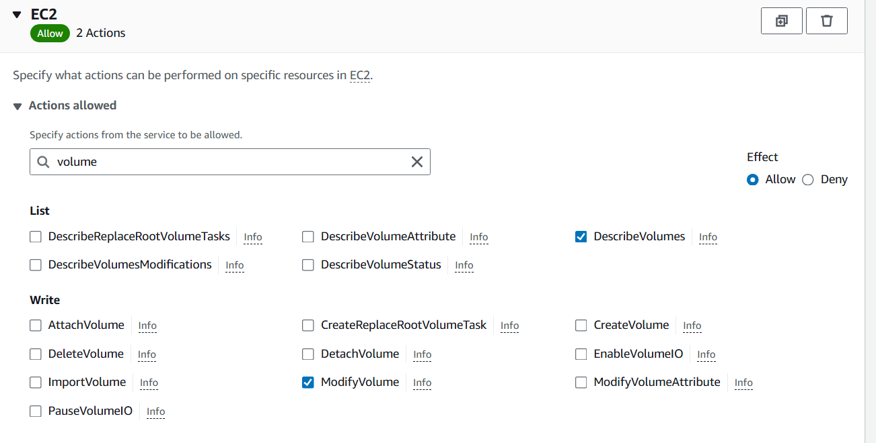

**Step 2: Create a CloudWatch Event Rule**

1. **Navigate to CloudWatch**:
   * Go to the CloudWatch console.
   * Select "Rules" under the "Events" section.
2. **Create a New Rule**:
   * Click "Create rule".
   * Configure the rule with the following settings:
     + **Event Source**: Select "AWS events".
     + **Service Name**: Choose "EC2".
     + **Event Type**: Choose "EBS Volume Notification".
     + **Specific Event**: Select "CreateVolume".

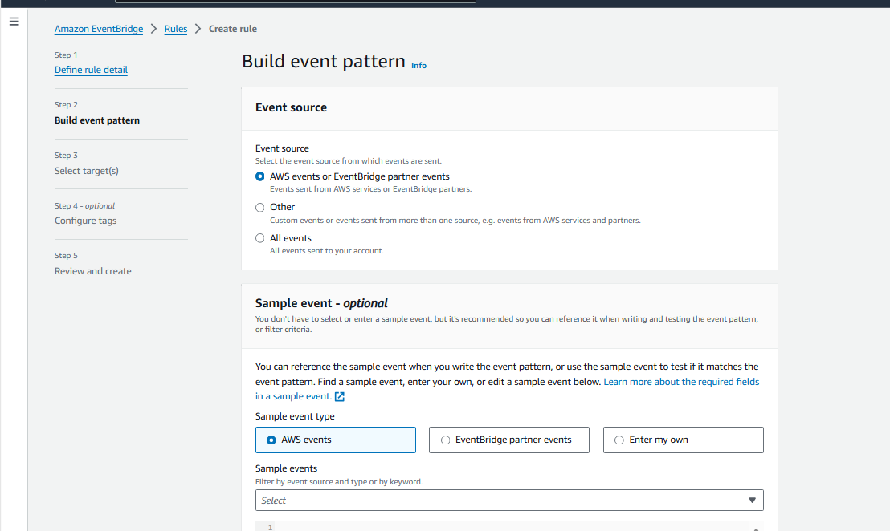

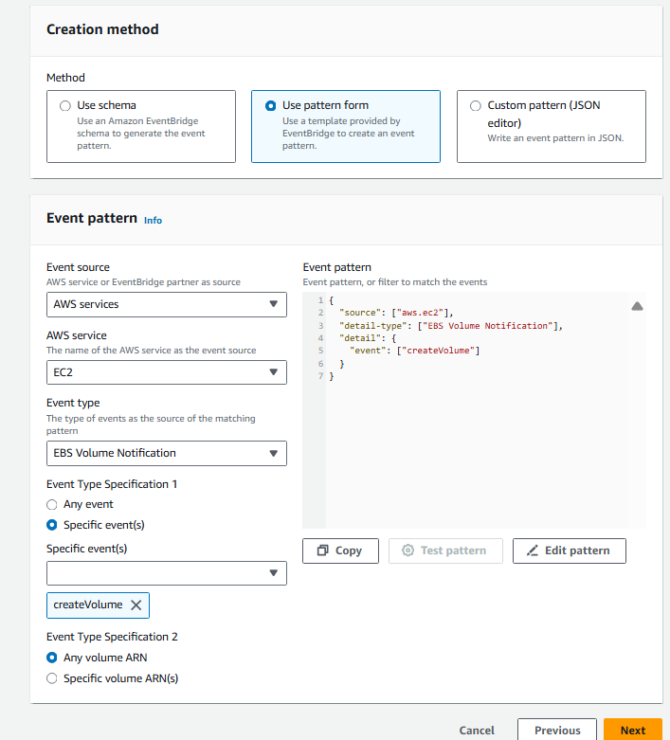

1. **Add Target**:
   * Add a target to trigger the Lambda function.
   * Select "Lambda function" and choose the function you will create in the next step.

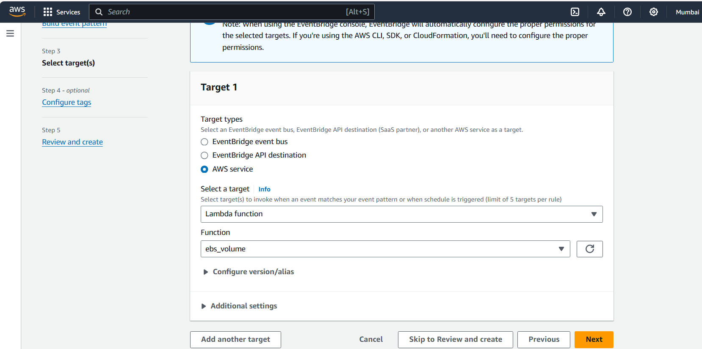

**Step 3: Create the Lambda Function**

1. **Navigate to Lambda**:
   * Go to the Lambda console.
   * Click "Create function".
2. **Configure the Function**:
   * Name: Convert GP2 To GP3.
   * Runtime: Choose a suitable runtime, e.g., Python 3.8.
   * Role: Choose the IAM role created in Step 1.
3. **Add Code**:
   * Use the following Python code as an example to describe the volume and modify its type:

import json

import boto3

def convert_volume_to_gp3(volume_arn):

ec2_client = boto3.client('ec2')

arn_parts = volume_arn.split(':')

volume_id = arn_parts[-1].split('/')[-1]

return volume_id

def lambda_handler(event, context):

volume_arn = event['resources'][0]

volume_id = convert_volume_to_gp3(volume_arn)

ec2_client = boto3.client('ec2')

response = ec2_client.modify_volume(

VolumeId=volume_id,

VolumeType = 'gp3',

)

1. **Deploy the Function**:
   * Save and deploy the Lambda function.

**Step 4: Test the Setup**

1. **Create a New GP2 Volume**:
   * Go to the EC2 console and create a new EBS volume of type GP2.
   * Ensure the volume creation triggers the CloudWatch Event and Lambda function.
2. **Verify Conversion**:
   * Check the Lambda function logs in CloudWatch Logs to confirm the volume type was changed from GP2 to GP3.

**Conclusion**

This setup ensures that any newly created EBS volume of type GP2 is automatically converted to GP3, maintaining compliance with organizational policies. Adjust the Lambda function and CloudWatch Event rules as needed to fit your specific requirements.